Ross Carvalho 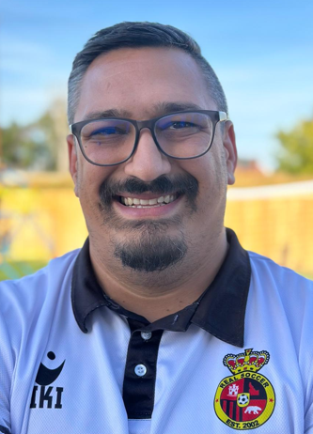

Playing Experience: I started playing the beautiful game as an 8 year old just outside of London, England and have been either playing or coaching ever since. I played throughout my school and college years at club level, mostly as a goalkeeper and have played in leagues and tournaments in multiple countries against teams from all over the world.

Coaching Experience: I started coaching in college, coaching our women's team and leading my men's team to a league win and promotion. I have been coaching with Real since 2023 with my oldest son, starting in the U6/7 academy and working our way to competitive. I also had the pleasure of coaching at the Real Madrid Foundation summer camp in 2024.

Goals: My goal is to teach kids to love the game, learn how to play with passion, respect and, most importantly, have fun. It makes me proud to see our players develop over time, picking up different skills and how they come together as a team.

